**International Institute of Professional Studies**

**Devi Ahilya Vishwa Vidhylaya**

**Indore M.P.**



SUB :- System Analysis And Design

III INTERNAL ASSIGNMENT

Submitted By : Submitted To:

Vishal Dhiman (IC-2k19-100) Mr Rahul Singhai Sir

MCA ( 6th Sem ) , Sec - B

**Bonafide Certificate**

This is to certify that the project entitled “Aahardaan” submitted to Devi Ahilya vishwa vidhyalya in partial fulfillment of requirement for the award of degree BACHELOR OF COMPUTER APPLICATIONS (BCA) is an authentic and original work carried out by Mr. Ram Gopal Singh (IC-2K19-67) and Mr. Vishal Dhiman (IC-2K-19-100) under my guidance.

The matter in this project is genuine work done by the student and has not submitted to this university or any other university (institute) for the fulfillment of requirements of any course for study.

Internal Examiner External Examiner

**RECOMMENDATION**

The Project work entitled “aahardaan” submitted by Ram Gopal Singh and Vishal Dhiman is satisfactory account of the work under my supervision and recommended towards the end of II year of B.C.A. 2021.

Guided By:

Mr Shaligram Prajapat

**ACKNOWLEDGEMENT**

We acknowledge our thanks to those who have contributed to this project directly or indirectly .Specially my team member, our parents who have encouraged and give their valuable support and our teacher Mr Shaligram prajapat sir thanking him for their effective suggestions who helped us in making of this project more efficient.

We acknowledge each and every one for their kind support and effort that helped us and we would like to extend our sincere thanks to them.

**ABSTRACT**

This project is part of charitable activities usually organised by civil society organisations sometimes supported by local and state government. The Project aims at developing a complete designed to cater every requirement in proper functioning of food donation.

It will help as providing platform for donating food items to the needy people and the people who want to donate the food. This includes information about donor, helper acting as a medium to connect the food donor and admin managing confirmation of donation and helper, donor’s feedback.

This will help the food donors to save their valuable time and money and reduce food wastage in locality and the poor and needy people to get the food without begging for it.

**TABLE OF CONTENTS / INDEX**

1. **Introduction**
   1. Overview/background

1.2 Objectives

1.3 Purpose

1.4 Applicability

1.5 Achievements

1.6 Organization Report

1. **Current and Existing System**

2.1 Current System

2.2 Existing System

2.3 Proposed System

1. **Requirements and analysis**
   * 1. Problem definition

3.1.2 Requirements Specification

* 1. Software and Hardware Requirements
  2. Preliminary Product Description
  3. Conceptual Models

1. **System Design**
   1. Database Design

4.2 Logic Design

4.2.1 Use of case diagram

4.3 Use of ER-diagram

1. **Conclusion**
2. **Future Prospectives**
3. **References**

**1. Introduction**

**1.1 Background/Overview**

Aaharrdaan is a mission to end hunger and no wasting of food to make the country hunger free. It manages the food items for the poor and needy people of different areas in city. It will help all poor and needy people, divided in 4 classes donar, helper, organization and admin. During the lockdown, a huge population gets affected through it which tells importance of food, groceries and many other items. It also maintain record of the donation, donator through which they can easily contact.

**1.2 Objectives**

The objectives of the development are as follow :-

* To relieve hunger by providing food items to persons .
* To help the needy and worthy people to get the food.
* Providing a stage to people who wanted to keep food excess in quantity from wastage and give it to poor, orphans and hungry peoples.
* To give new information and reveals a different point of view about different social issues.
* Maintaining all records of aspect related to donation.
* Receiving the feedback from donor about the food donation.
* To increase more and more people, social organisations, communities to donate food items.

**1.3.1 Purpose**

Aahardaan is a mission to end hunger and reduce the wastage of food to make the country hunger free. This is a major problem of country that has chosen as every people of country does not get meal everyday in their daily life. The project improves the food donation service in a digital way by providing a stage to the person who wanted to help and feed the poor, hungry and needy people by saving their money and time.

**1.3.2 Scope**

The main issues that has been covered with this project is that it will encourage the people about their value able food donation service and make aware them about large amount wastage of leftover food. And the functionality of this system is to reduce food wastage by providing it to poor, hungry people that need that food.

**1.3.3 Applicability**

This project will directly or indirectly affect the food donors, needy peoples which require food as their need for survival. And this will help to know the actual reality of poor peoples and increasing harmonious, friendly relationship between them. It will create a new view to look at different social issues in the society.

**1.3.4 Achievements**

We will learn from this project that the donation is a service to mankind how it has to be in a effective and efficient manner in today’s world by making it online in a digital version so that everyone can connect easily. It will help to get the knowledge that how the donation system will work digitally and we can help virtually. How to donate ,how to get food and how to connect, how the whole process works digitally.

**1.3.5 Organization of report**

We can donate the food online with the help of different web interfaces, applications etc. We have analysed the topic food donation clearly and mentioned the requirements which are necessary for the system .Especially for feedback and door to door service to provide ease to food donors.

**2. Current system and Existing system**

**2.1 Current System**

The current system that is used in Online Food Donation is completely manual. It gives the information about various donations of food is maintained as a record. But it can provide only one organization or charity at a time to donate food. This website will help to provide information regarding food to different organization or any individual which want to help to feed the hungry. It also maintain a record for donation details in the database and take feedback about donations.

**2.2 Existing System**

Presently people who wish to donate items need to personally visit the organizations and donate foods or other items. Otherwise, they have to search for some websites to donate surplus food.In general, the large manufacturers, wholesalers, and organized community provide food items to food banks or waste tons of foods daily. They have to search for some organization that needs food. This process involves a lot of time to contact the organization to check the requirement. If they do not need the food, then the person has to contact another organization. This makes the donor tired and exhausted.

**2.3 Proposed System**

The website for food donation acts as an interface between the users who are looking for a channel to give the excess food without wasting it.It enables us to donate the excess food by notifying nearby users with the details of the food that is available. The required users claim the notification. The system allocates the food items based on the priority.In proposed system we are reduce that food wastage. This project is food redistribution is an enormously successful social innovation that tackles food waste and food poverty. The admin collect foods from donator through their nearby agent then provide to nearest orphanages or poor people. After receiving the food from the agent by admin and give alert message to that donator through this way we can reduce food wastage problem.

**Foods Suitable for Donation**

**Home-Prepared Foods**

DONATED FOOD DISTRIBUTING ORGANIZATIONS are not allowed to accept or serve most types of home prepared foods. However, homemade baked goods that do not need refrigeration to remain safe (such as cookies, cakes, fruit pies, and breads) may be received from DONORS

##### Commercially Packaged Foods Not Needing Refrigeration

The donation of commercially canned, boxed, and otherwise packaged foods is encouraged.

##### Food Donation by Food Processors

Food processors are encouraged to donate foods that may not meet their specifications for reasons that do not affect food safety, such as package printing errors. Each food package may lack complete labeling required for commercial distribution, as long as the charitable distributing organization is given enough information to mark each container with the common name of the food. At least one accurate, complete label must be provided with each master carton.

##### Fresh Produce Donations

Food donations may include fresh produce, including home-grown fruits and vegetables. Fresh produce should be protected from contamination and receive final preparation.

**3. Requirements and analysis**

**3.1.1 Problem Definition**

The following points to describe the problem are:-

* Many persons have food wastage related issues in the society.
* It becomes difficult for poor to get food daily.
* Sometimes it is not easy to find poor and needy persons who need food everywhere and takes a lot of time to search them that makes donor tired and exhausted.
* Not all time food material find at particular place.
* Many of times some persons eager to help poor but they don’t have enough ways to help them.
* Especially in lockdown thousands of persons have to suffer for food items due to their hunger and requirement as there is no source of income for them.

**3.1.2 Requirements Specification**

1. Sign in or Register to website to donate surplus food in which the user can clearly mention his role whether it is donor, helper or receiver.

2. After registering the user has to create request in which clearly mention the food item type, quantity, pickup time so that the helper can easily contact with him and collect that surplus donation.

3. The helper has to collect the food items from the donator and give it to the organisation or individual through which he/she belongs.

4. After the completion of donation of food the request of donor or receiver remove from the interface then new request sorted based on priority will process further.

4. If for a request the request amount is greater than the amount present, then partially fulfill that request by the amount present. And do not delete that request from the request table; just reduce its amount by the amount that is fulfilled.

5. If in the process of fulfilling the request, the amount present for any donation becomes zero, then remove that donation from website.

6. After every donation completed the donor gets a thank you message on email provided and both the donor and receiver can give their feedback about the donations.

**Input/Output Specification**

At the beginning, the website should present the user with the available options, and ask for his/her preference. Based on the preference, the request should perform the corresponding task.

The user will have 6 choices:

1. Sign in/Register

2. Enter donation quantity & Items

3. Request created and processed

4. Completion of request

5. Feedback about donation

6. Exit

**3.2 Preliminary Project Description**

**Aim**

To design a web system for the poor and needy people in community, so as to make the task of donation more efficient, effective using the database design concept. Donating food to poor helps to counter poverty, hunger and canimprove harmony, friendliness among citizens. The aim of this project is reduce amount of food wasted and more and more used by needy people and help all the persons in the country which have to suffer due to food problems. This interface enables us to donate excess food by notifying nearby users with the details of food that is available. The system allocates food items based on the priority.

**Project Goals**

1. To build a platform for food donation system in a digital version.
2. Promote increased level of happiness, goodwill among societies and communities.
3. Reduction in the wastage of food materials in the society, community by giving it to worthy and needy peoples.
4. Helping the required persons in either or in every crisis situationas service to mankind.

**Benefits of food donation**

* Donating to needy is great way to improve conditions in neighbourhood and community.
* Saves time and effort - To pick up food donations free of charge, saving donors time and money.
* Reaching at restaurants, hotels, large manufacturers and events in schools, collages and community that they could donate wholesome food that will be wasted.
* **Reduces methane emissions** from landfills and lowers your carbon footprint.
* **Conserves energy and resources**, preventing pollution involved in the growing, manufacturing, transporting, and selling food (not to mention hauling the food waste and then landfilling it).
* **Supports your community** by providing donated untouched food that would have otherwise gone to waste to those who might not have a steady food supply.

**3.3 Software and Hardware Requirements**

**Hardware->**Processor: Intel Xeon e5440 @2.83GHz

Memory: 5 GB Network Card required

Disk space:20GB (4GB for database files +enough space for shared documents, Individual)

**Software->** Easy projects does no run on Microsoft SQL Server. It is also

Possible to provide a complete virtual machine –VM Ware so don’t worry

about the configuration at all.

Software (client)

Chrome(<http://www.google.com/chrome>) Microsoft Edge

**Operating System->** Centos Tested OS X not supported Windows server not actively supported Other Linux distributions Not tested may have very specific requirements.

**3.4 Planning and Scheduling**

The planning and scheduling issues mostly focus on the design and operation of efficient connection networks.

**Gantt chart**

A Gantt chart, commonly used in project management, is one of the most popular and useful ways of showing activities (tasks or events) displayed against time. On the left of the chart is a list of the activities and along the top is a suitable time scale. Each activity is represented by a bar; the position and length of the bar reflects the start date, duration and end date of the activity.

|  |  |  |  |  |  |  |  |  |
| --- | --- | --- | --- | --- | --- | --- | --- | --- |
| Phases |  | March |  | April |  |  | May |  |
|  | 1-15 | 16-31 | 1-10 | 11-20 | 21-31 | 1-10 | 1-15 | 16-31 |
| Analysis |  |  |  |  |  |  |  |  |
|  |  |  |  |  |  |  |  |  |
| Requirements |  |  |  |  |  |  |  |  |
|  |  |  |  |  |  |  |  |  |
| Planning |  |  |  |  |  |  |  |  |
|  |  |  |  |  |  |  |  |  |
| Design |  |  |  |  |  |  |  |  |

**Pert Chart**

A PERT chart is a visual project management tool used to map out and track the tasks and timelines. The name PERT is an acronym for Project (or Program) Evaluation and Review Technique. It is a project management tool that provides a graphical representation of a project's timeline. The Program Evaluation Review Technique (PERT) breaks down the individual tasks of a project for analysis. PERT charts are considered preferable to gantt charts because they identify task dependencies, but they're often more difficult to interpret.

requirement

analyse

plann

design

Implement

Introduction

III

conclusions

coding

testing

**3.5Conceptual Models**

**Data Flow Diagram**->A data flow diagram (DFD) maps out the flow of information for any process or system. It uses defined symbols like rectangles, circles and arrows, plus short text labels, to show data inputs, outputs, storage points and the routes between each destination. Data flowcharts can range from simple, even hand-drawn process overviews, to in-depth, multi-level DFDs that dig progressively deeper into how the data is handled. They can used to analyze an existing system or model a new one.

**ER Diagram** ->An Entity–relationship model (ER model) describes the structure of a database with the help of a diagram, which is known as Entity Relationship Diagram (ER Diagram). An ER model is a design or blueprint of a database that can later be implemented as a database. The main components of E-R model are: entity set and relationship set.An ER diagram shows the relationship among entity sets. An entity set is a group of similar entities and these entities can have attributes. In terms of DBMS, an entity is a table or attribute of a table in database, so by showing relationship among tables and their attributes, ER diagram shows the complete logical structure of a database.

**Flowchart** ->A flowchart is simply a graphical representation of steps. It shows steps in sequential order and is widely used in presenting the flow of algorithms, workflow or processes. Typically, a flowchart shows the steps as boxes of various kinds, and their order by connecting them with arrows. They help us visualize complex processes, or make explicit the structure of problems and tasks. A flowchart can also be used to define a process or project to be implemented.

**Unified Modeling Language (UML)** -> UML is a general purpose modelling language. The main aim of UML is to define a standard way to visualize the way a system has been designed. It is quite similar to blueprints used in other fields of engineering.UML helps software engineers, businessmen and system architects with modelling, design and analysis.

**4. System Design**

**4.1 Data Design**

* Sign-up and login: The user has to sign in with the name, email ID, contact number, and address.
* Donating the surplus food: The user has to choose the activity if donating or claiming the surplus food. It is required to fill the contact address where the food is available.
* Claiming the surplus food: If the user claims for the surplus food, need to specify the organization name with address and contact details.
* Priority-based sorting: If one or more user has claimed for food, the request is scheduled on priority bases.
* Data Analysis with Graphs: The data gets recorded after every donation and the graph is prepared for visualization impact. This graph is prepared with the focus of increasing donating in the minds of people.
* Data Analysis with Reports: Once the data gets recorded, the system generates reports with the total number of people fed and the total quantity of food donated.

**4.2 Logic Design**

This design describes the functions required of a system those are:-

**4.2.1 Use of case diagram**

Receiver

Donor

Admin

Helper

**4..3 Entity Relationship Diagram**

**4.3.1 Entity**

An entity can be a real-world object, either animate or inanimate, that can be easily identifiable. For example, in a school database, students, teachers, classes, and courses offered can be considered as entities. All these entities have some attributes or properties that give them their identity.

An entity set is a collection of similar types of entities. An entity set may contain entities with attribute sharing similar values. For example, a Students set may contain all the students of a school; likewise a Teachers set may contain all the teachers of a school from all faculties. Entity sets need not be disjoint.

**4.3.2 Attributes**

Entities are represented by means of their properties, called attributes. All attributes have values. For example, a student entity may have name, class, and age as attributes.

There exists a domain or range of values that can be assigned to attributes. For example, a student's name cannot be a numeric value. It has to be alphabetic. A student's age cannot be negative, etc.

**4.3.3 Relationships**

Any association between two entity types is called a relationship. Entities take part in the relationship. It is represented by a diamond shape.

Donate food

***For example,*** A teacher teaches students. Here, "***teaches***" is a relationship and this is the relationship between a Teacher entity and a Student entity.

Entities

* Name: Donor Identification - Donor phone number
* Name: Helper Identification - Helper ID
* Name: Organization Identification - Org_name
* Name: Admin Identification - Admin password
* Name: Type Identification – Type name
* Name: Item Identification – Item quantity
* Relationships
* Binary Relationships
* **One to One**

Donor <-> Helper

* **One to many**

Helper <-> Organization /charity

Organization <-> needy people

Helper

H_name

H_phoneno.

H_adress

H_city

Receiver

R_name

R_phoneno.

R_address

R_city

R_email ID

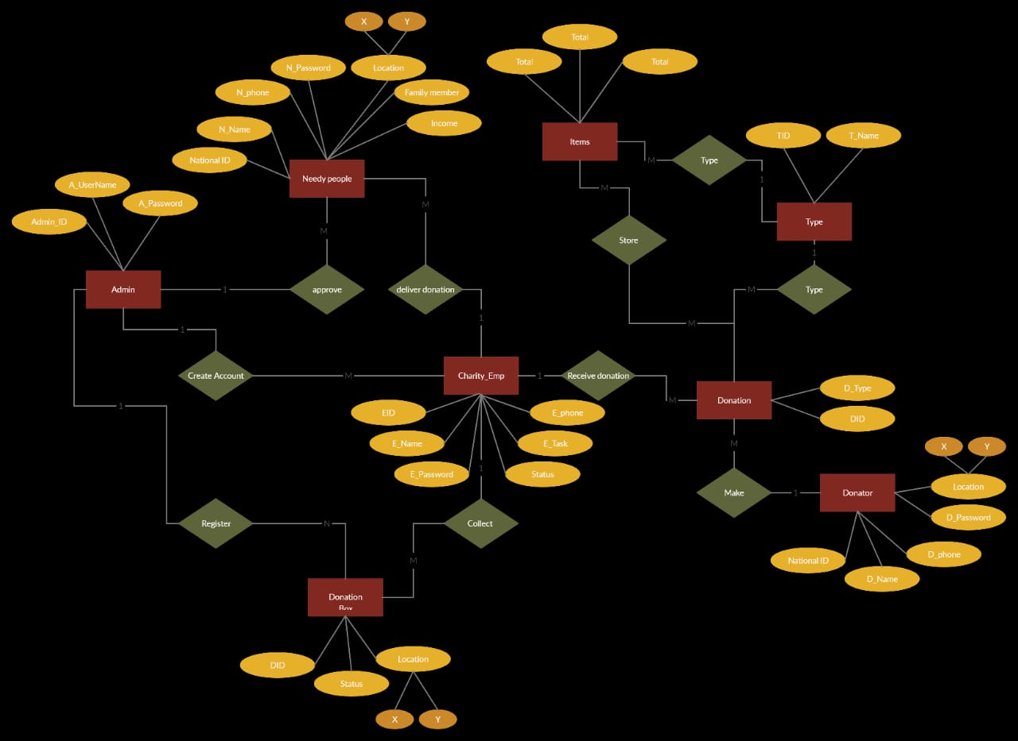

Gives

Donor

D_name

D_phoneno.

D_email ID

D_address

D_city

**5. Conclusion**

The surplus food from the functions and gatherings can be donated easily. The visualization impact of the donation can create a positive impact on the users.  Minimizing food wastage and feeding the hunger is the main goal of the food donation project. The interface is targeted in two ways, the user who is donating the food and the person/organization that is claiming the food.

As mentioned above in the description there is a lot of food wastage that occurs daily at restaurants, events, hotels, cafes. Instead of throwing away the same as trash (which usually is the scenario), it can be used to feed the homeless. Also, since the pickup is arranged for by the enterprise, the restaurants/cafes need not worry about it. Benefiters will be both the restaurants, hotels, cafés etc (reducing the carbon footprint and wastage), and the needy.

The excess food produced in functions gatherings can be easily donated. Visualization of the impact of donation has a positive impact on the users. An effort focused on feeding the hunger and minimizing food Wastage at the same time.

A Website which can used to donate or claim the excess food.Donating the excess food that provides the location of where excess food are available &details of the food quantity available and sends immediate alerts to nearby NGO's, orphanage, volunteers to collect them.

**6.Future Prospectives**

* A door to door pickup and drop service for food can be executed.
* Donors can donate any food item with any food quantity directly to help.
* Donor can find different organizations at one place so no need to go anywhere.
* Food donation process become more effective and fluent with some other services.
* Both the donor and receiver can give their feedback so that the service will improve day by day.
* It will help the poor and needy in every critical condition especially in nowadays like pandemic, lockdown.
* Build harmonious relations between persons of different background, different communities.
* Also will make citizens more aware about different social issues so that each one can think of them and will try to help the hungry and poor persons in any of way he/she can help.
* Reduce the large quantity of food wastage by giving that surplus food to hungry and needy peoples.

**7. References**

1. Available at https://drive.google.com/file/d/0B1m77YndfAXlbmN4ZTYya2VTUGlDQnB6V3IwVWFrUQ
2. Available at - <https://projectsgeek.com/2020/02/food-donation-project-system-free.html>
3. Available at - <https://www.irjet.net/archives/V7/i3/IRJET-V7I378>
4. Available at - <http://ijarcet.org/wp-content/uploads/IJARCET-VOL-5-ISSUE-4-906-908.pdf>
5. Available at - <https://www.researchgate.net/publication/284726800_Food_donation_An_initiative_to_mitigate_hunger_in_the_world>
6. Available at - <https://www.rescuingleftovercuisine.org/>
7. Available at - [www.annakshetra.org/](http://www.annakshetra.org/)
8. Available at - <https://www.globalgiving.org/projects/>